# TELEMETRY UNIT

Range should cover distances up to 600m, to cover all common race tracks. Reliability of the connection should be tested with little to no obstacles in between, as is the case on track. A suitable technology and operating frequency are chosen to transmit the data from the VCU to a laptop close to the race track.

Key goals of the implementation must be flexibility and ease of use, as well as minimum weight and form factor of all physical parts in the race car.

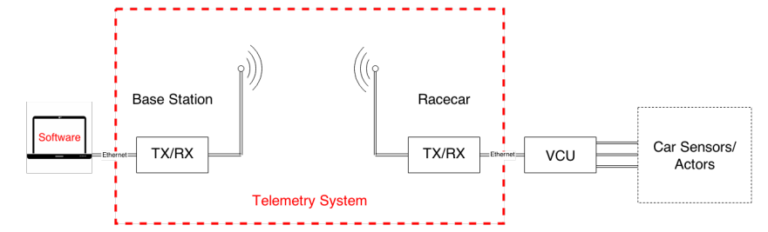

ZigBEE: suitable for low cost and low power devices, can operate in multiple frequencies but has insufficient nominal max throughput and small range depending on the power of the device

Bluetooth: simple setup of connections and robustness to interferences, nominal throughput up to 24Mbps. Small range, low availability of high-power devices and limited to USB-A and B type connectors, not provided on VCU.

Cellular Networks: provide high data rate but commercially licensed frequency bands. using service provider’s network is unreliable as it depends on the network coverage on the track, may be used by several other people on the track and can be expensive for large data transfers.

WLAN: High data rate, easily connects to wide range of devices and low latency, may be prone to interference from other networks and power-intensive

Other technologies that can be implemented include Radio Frequency Communication and Long Range (LoRa) Technology but are complex to implement than the above mentioned technologies.